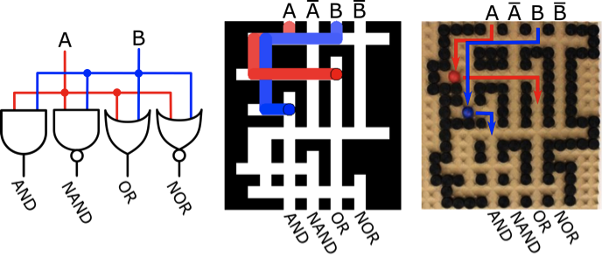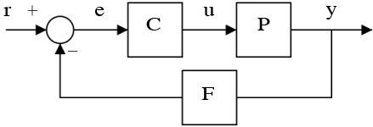­­­­­­­­

Thank you for coming today! [atbecker@uh.edu](mailto:atbecker@uh.edu) Please help us out and

1. Play 5 games at [SwarmControl.net](http://swarmcontrol.net) *This project has been reviewed*

*by the University of Houston Committee for the Protection of Human Subjects (713) 743-9204.*

1. Click “like” or “share” button on [SwarmControl.net](http://swarmcontrol.net)
2. Subscribe to my robotics research YouTube channel: [aabecker5](http://www.youtube.com/user/aabecker5)

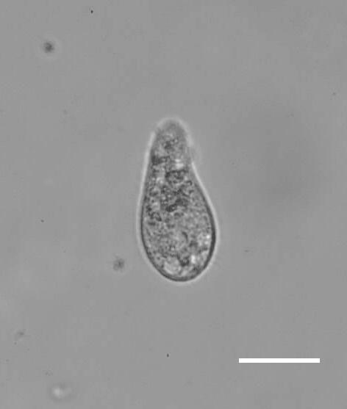

.025 mm

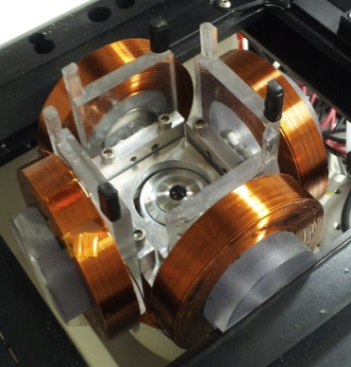

65 mm

Our research is motivated by real-world challenges in micro- and nanorobotics, where often all robots are steered by the same control.

Current algorithms are slow, so we're designing new algorithms that are 200x faster. You can help by playing our game: [swarmcontrol.net](http://swarmcontrol.net/)

We focus on models using broadcast control inputs. I provide control-theoretic results and control algorithms. Through extensive testing with human subjects we demonstrate many manipulation tasks can be reliably completed, even by novice users, under this system model.

Results are validated with hardware experiments using over 100 robots, extensive simulations, and over 10,000 human-user trials

We 1 summer researcher position remaining for someone with OMPL training, and a desire to attack a new problem.

*Images:* (CW) orthogonal electromagnetic coils for steering magnetized living cells, motivating underactuated motion planning problem in a vascular network, Boolean *dual-rail* gates

***Massive Uniform Manipulation*** *Aaron Trent Becker*

University of Houston (this coupon = free lab tour)

Experiments

(video)

Page 2 of 2

Page 1 of 2

­­­Feedback form (please return to speaker) name (optional)

email (optional)

1. What items were **unclear**? (Please use slide #s)
2. What **motion planning techniques** would be applicable to many robots with global control?
3. How could the **research be improved**, i.e. more/better experiments (how?), better motivation, read literature on *X*
4. Do you have any questions? (Please give your email)
5. Further comments (Suggestions for improvement)